 

## Deep Learning in Age-Invariant Face Recognition

Class: Duration time: from 01/2023 to 4/2023

(*) Profession: <AI Engineer> Specialty: <ES> <IS> (*) Kinds of person make registers: Lecturer Students

x

Register information for supervisor (if have)

|  |  |  |  |  |
| --- | --- | --- | --- | --- |
|  | **Full name** | **Phone** | **E-Mail** | **Title** |
| Supervisor 1 | Nguyễn Quốc Trung | 0979350707 | TrungNQ46@fe.edu.vn | Mr. |
|  |  |  |  |  |

Register information for students (if have)

|  |  |  |  |  |  |
| --- | --- | --- | --- | --- | --- |
|  | **Full name** | **Student code** | **Phone** | **E-mail** | **Role in Group** |
| Student 1 |  |  |  |  |  |
| Student 2 |  |  |  |  |  |
| Student 3 |  |  |  |  |  |
| Student 4 |  |  |  |  |  |

Register content of Capstone Project (*) 3.1. Capstone Project name:

# English: Deep Learning in Age-Invariant Face Recognition

**Vietnamese: Nhận dạng khuôn mặt bất biến theo thời gian bằng học sâu**

Abbreviation:

Describe:

In today's world, face recognition is widely used. The ability to find missing children and identify them even after they have grown up is one of the uses for age-invariant facial recognition. Additionally, it can be used to check a watch list and look up suspects who have been missing for a long time. The main challenge for these applications is the lack of adequate gallery photographs with subjects at various ages that can be used to create recognition models.

Human faces can change dramatically over time in a variety of ways, including facial texture (such as wrinkles), shape (such as weight increase), facial hair, the use of glasses, etc. This makes the work at hand complex. Additionally, the surroundings and image acquisition settings may alter, which may result in scale and uniform lighting changes.

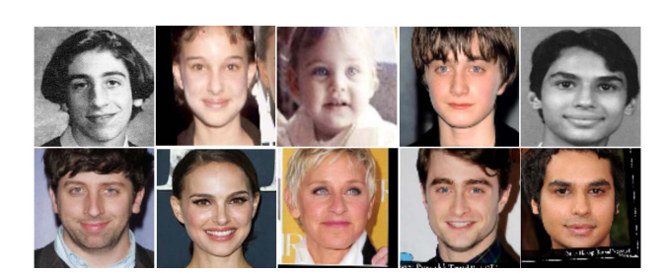

Fig: Examples of effect of aging on human faces. Top image is a childhood images of celebrities and the corresponding images below those are the adult images of same celebrities [1].

Context:

Due to biological changes in the anatomy of the face, such as changes in muscle, skin, and color, the human brain is capable of remembering and recognizing a person despite complicated changes. As time passes, the brain cannot become less able to recognize a person due to the ability to modify facial expressions and facial bones. There is a growing need for computer vision systems in automatically detecting faces with the following variation because people constantly desire computers to become more powerful and smarter like themselves. When undergoing plastic surgery, altering the image too much, such as by changing the angle at which it was taken, the distance at which it was taken, the brightness of the image, or even by using image editing software.

Over the past few years, many cross-age datasets have been provided. In this capstone project, we will use some dataset for training and testing: Large Age Gap (MLAG) Dataset [2], FG-NET [3], CARC [4].

# Objectives:

+ Deep learning approaches for Age-Invariant face recognition: convolutional neural networks (CNNs) and RNNs.

+ Evaluation the result on other dataset.

(*) 3.2. Main proposal content (including result and product)

Theory and practice (document):

+ Researching about Deep learning algorithm and build the models for Age-Invariant face recognition.

+ Build a simple web prototype that integrates with models.

+ Students should apply their knowledge about IMP301, AIL302m, AIP391, DPL301m, PRJ301 and their deep programming and skills that they get based on their curriculum or OJT when they do capstone in progress.

References:

[1] S. Bodhe, P. Kapse and A. Singh, "Real-time age-invariant face recognition in videos using the scatternet inception hybrid network (SIHN)", *Proc. - 2019 Int. Conf. Comput. Vis. Work. ICCVW 2019*, pp. 1112-1120, 2019.

[2] <http://www.ivl.disco.unimib.it/activities/large-age-gap-face-verification/>.

[3] <https://yanweifu.github.io/FG_NET_data/>

[4] https://bcsiriuschen.github.io/CARC/

Program:

Other products: N/A

Other comment (propose all relative thing if have)

# Supervisor (If have)

(Sign and full name)

HCM, 12/2022

# On behalf of Registers

(Sign and full name)